U. S. District Court
Western District of Louisiana
“Applicable Party” changes to certain criminal filings for Attorney Users
Effective: 3/1/2020

The Office of U. S. Probation and the Clerk’s Office for the Western District of Louisiana are excited to implement “applicable party” features in our CM/ECF system! Listed below are the events and processes that will affect all U. S. Attorneys, Federal Public Defenders, CJA panel attorneys and retained counsel in criminal cases:

- Presentence report
- Objections to presentence report

The presentence report will have appropriate defense and government attorneys selected by court staff during entry. CM/ECF sends a Notice of Electronic Filing only to those selected and allows them access after validation of login and password credentials. Receipt of this email constitutes verification of the receipt and delivery of the presentence report.

Noticing and accessing the documents:

From the NEF (Notice of Electronic Filing):
- Click the document number link in the email.
- At the login prompt, enter the attorney’s PACER login and password.
- Check the redaction rules check box.
- Click Login.
- On the warning page, click View Document.
- When the document displays, save or print as desired.

From a CM/ECF Query:
- Log into the Western District of Louisiana’s CM/ECF system, checking the redaction rules check box.
- Select Query from the blue menu bar.
- Enter the case number.
- Click Docket Report.
- On the Docket Sheet options page, check Restricted entries. Click Run Report.
- On the docket sheet, click the appropriate document number link.
- On the warning page, click View Document.
- When the document displays, save or print as desired.

Making a filing:

Similarly, attorneys filing objections to presentence reports will file directly into the court’s record, selecting only the applicable parties so appropriate defense and government counsel receive notice and may access the document:

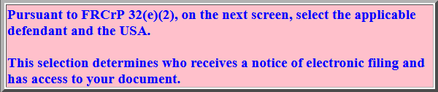.

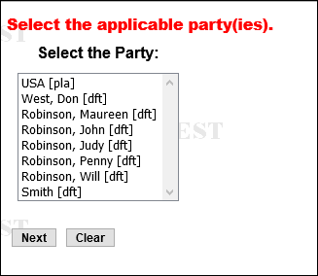
To select 2 parties, hold the control key and select the government and appropriate defense counsel.

No more need for courtesy copies!

If you have any questions, please call your local U. S. Probation Office or the CM/ECF Help Desk at 1-866-323-1101.

